2023

User's Guide to the Network testing complex "Online test"

WEBSITE ADDRESS: HTTPS://ONLINE-TEST.KAZNU.KZ/
FOR ROLES: applicant

КАЗАХСКИЙ НАЦИОНАЛЬНЫЙ УНИВЕРСИТЕТ ИМ.АЛЬ-ФАРАБИ, ИНСТИТУТ ИНФОРМАЦИОННЫХ ТЕХНОЛОГИЙ И ИННОВАЦИОННОГО РАЗВИТИЯ| Отдел Информационной Поддержки
Управленческой Деятельности

How to register on the online-test website.kaznu.kz as an applicant?

To enter the network testing complex, follow the following link: https://online-test.kaznu.kz/

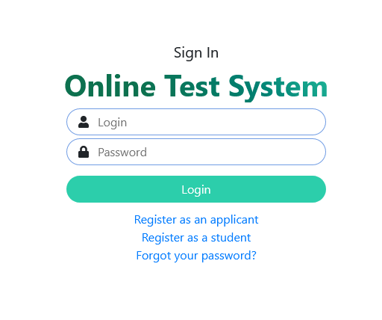

Picture 1 - Link for registering an Applicant

Ї Click on the link "Register as an applicant »
Ї Fill in the fields of the registration form:

Login | e-mail
Password | Contact phone number
Confirm your password | Ccountry
Surname | Region
Name | District
Middle name | City/Village
IIN *in this point put 123456789123 | School
Birth date | Grade
 | Year of graduation

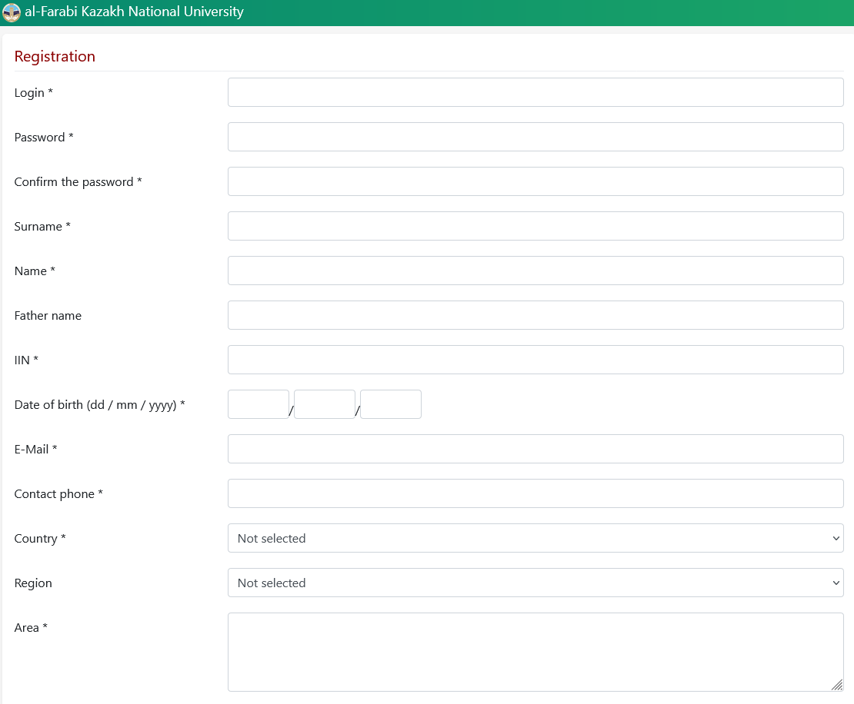

Picture 2 - Questionnaire for registration of applicant data - Part 1

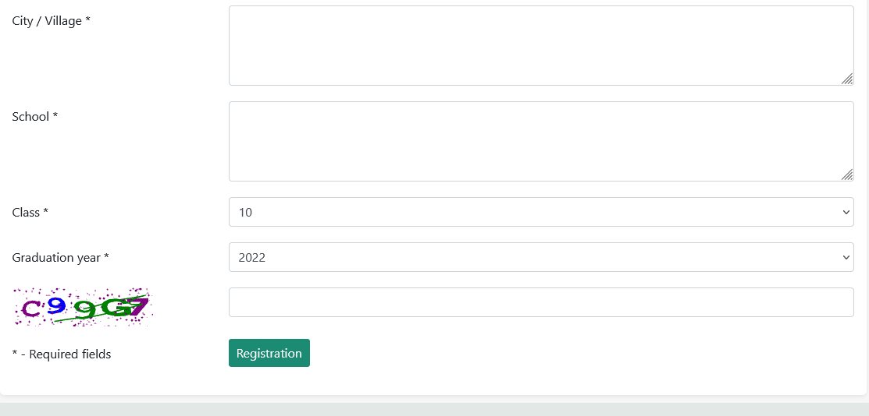

Picture 3 - Questionnaire for registration of an applicant - Part 2

How to start the testing process?

In order to start taking the test:
Ї Go to the Main page of the site. (Picture 4)

Picture 4 - Link to the main page of the site

Ї Select the name of the test and the testing language (Picture 5)
Ї Click on the "Start Test" button
Ї After that, a window with questions will open (Picture 6)
Ї After passing the test, click on the "Finish" button.
Ї You will see the Protocol with the test results (Picture 7)
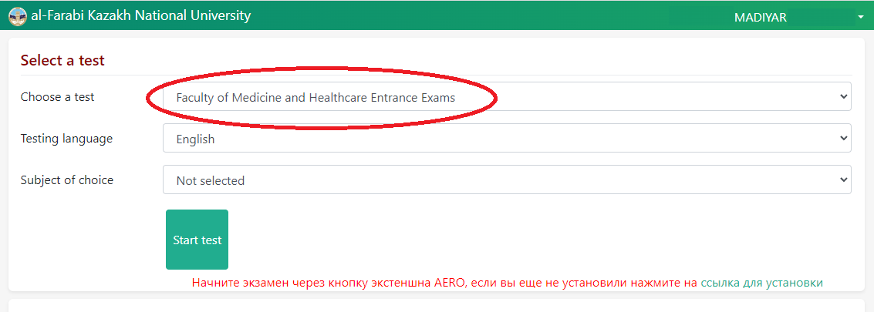
Picture 5 - How to start the test?
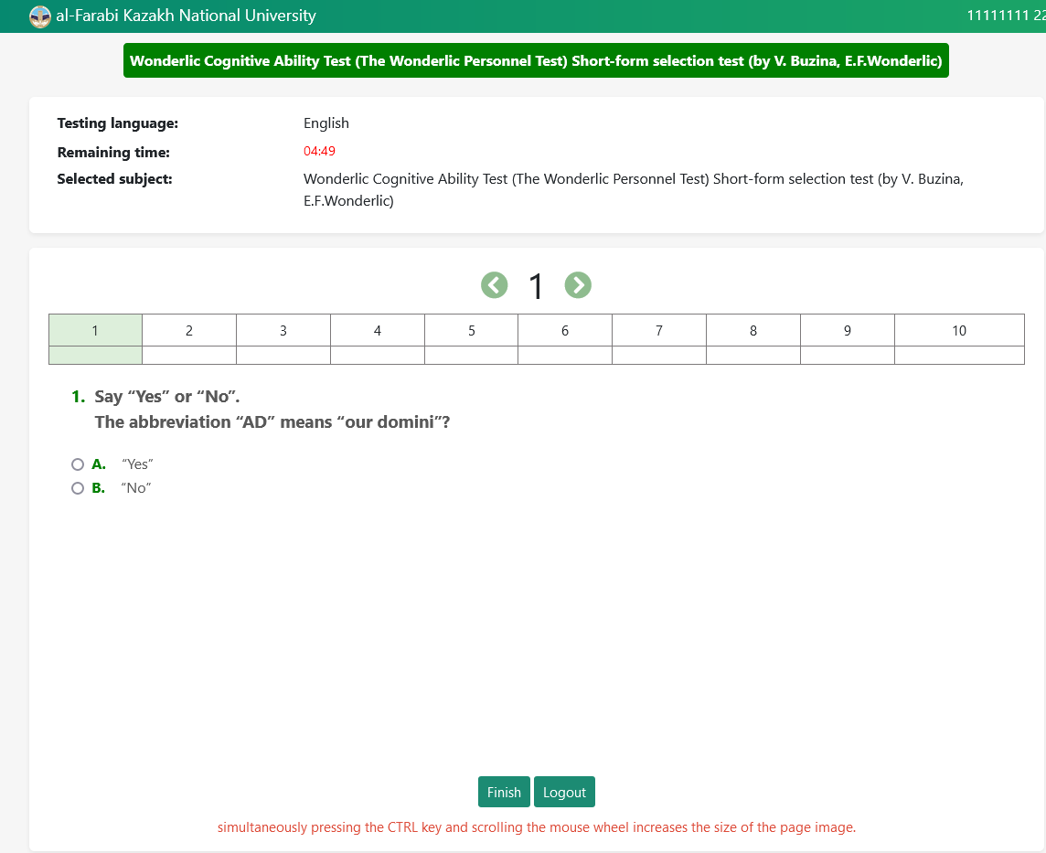

Picture 6 - Question window

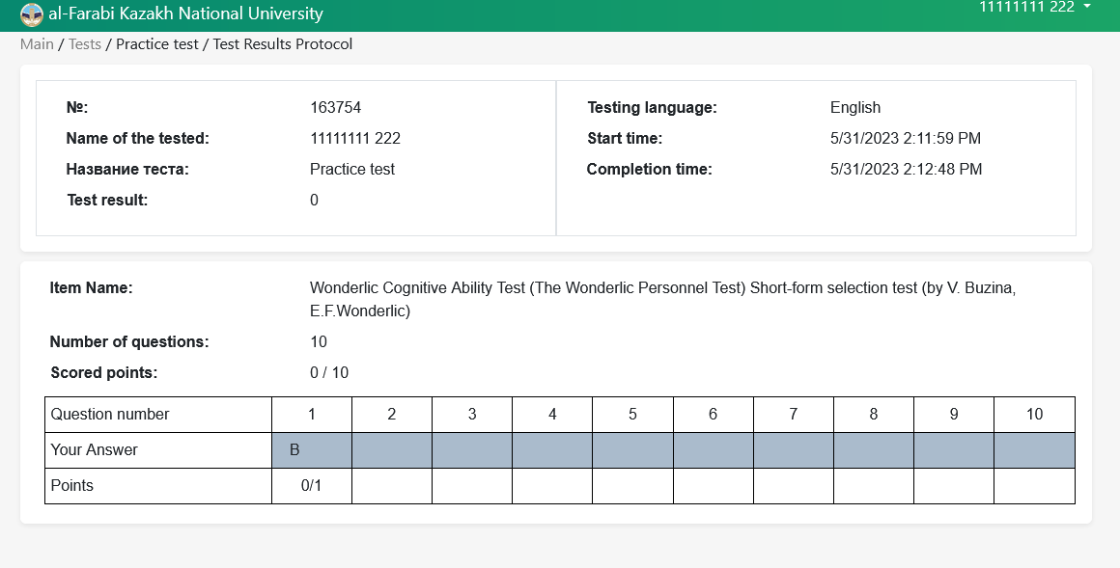

Picture 7 - Test results protocol

